Architectural document
This paper explains the architectural choices behind a Telegram-driven page generation system for EXPOZY. The system converts user prompts into a structured, validated page template using Google Cloud AI, while enforcing tenant permissions, security policies, and operational controls. Because the current backend is a custom synchronous PHP stack without a true event bus or pub/sub, the design uses a database-backed job queue and a cron/daemon Worker for asynchronous execution. A separate AI Generator Service isolates AI credentials and concentrates schema validation/repair logic. A Preview Web/Sandbox provides expiring, signed preview URLs and safe rendering using allowlisted components and strict browser security controls.
1. Background and Constraints
1.1 Current backend
The current backend is built as a custom PHP application running behind Apache, where URL routing is handled by mod_rewrite and requests are dispatched directly to PHP entry points. Because it is not based on a framework like Symfony or Laravel, it doesn't come with a standard queue system, background worker tooling, or a built-in "job" abstraction that can be reused out of the box. In practice, that means most work is performed inside the lifecycle of an HTTP request: when the server receives a request, PHP executes the code from start to finish in one continuous, blocking flow, and only then returns a response.
This matters because the backend processes events synchronously as well. Instead of publishing an event to an asynchronous bus where listeners handle it later, the code triggers events through a direct switch/case dispatcher. When an event is raised, the corresponding actions (sending emails, SMS, logging, etc.) happen immediately inside the same request. There is no listener registry, no message broker, and no background worker infrastructure that would naturally pick up tasks and run them later.
Although Redis and Memcached exist in the codebase, they are used in a way that supports caching rather than asynchronous processing. Redis appears as a driver option, but it is not actively integrated as a pub/sub system or a queue. Memcached is configured and used for templating and session-style caching. In other words, the system has mechanisms for speeding up reads and reducing recomputation, but not for reliably moving long-running work out of the request path.
The one proven mechanism the platform already relies on for doing work outside HTTP requests is scheduled CLI execution through cron. The project already has cron entry points and scheduled tasks, and those scripts can run PHP code with the same autoloading and database access as the web layer. Because cron is already part of the operational model, it becomes the most natural way to introduce asynchronous behavior: instead of trying to retrofit an event bus or introducing a new queue technology immediately, work can be enqueued in the database and have cron-driven workers process it in the background.
1.2 AI Generation
AI generation is not a good fit for the normal /api/* request lifecycle because the call to Google Cloud AI is a remote network operation whose latency and availability you don't control. Google's own Vertex AI Generative AI documentation describes transient capacity and quota conditions (for example HTTP 429) and recommends retrying after a short delay, which indicates that requests can be intermittently rejected even when your implementation is correct (Google Cloud, n.d.-c).
In a synchronous Apache + PHP setup, that uncertainty becomes a scalability problem because each HTTP request is handled by a limited pool of server workers. Apache's process/thread model is finite and is governed by worker-related limits (such as MaxRequestWorkers), so a long-running request consumes capacity that would otherwise serve other requests (Apache Software Foundation, n.d.). On top of that, PHP enforces execution time limits (commonly max_execution_time), meaning slow upstream calls increase the chance of the request being terminated mid-flight or timing out somewhere in the stack (The PHP Group, n.d.). When a timeout happens, the user experiences it as a failure even if the AI generation might complete shortly afterward, and the system can end up in an ambiguous state where it is unclear whether to retry, whether the previous attempt finished, or whether a retry would create duplicate output.
Retries and error handling are also much harder to do safely inside a single web request. Retrying inline keeps the request open longer, increases the chance of hitting web-server or PHP timeouts, and reduces throughput under load. If you avoid inline retries, you still need a durable mechanism to re-attempt transient failures like 429, record attempt counts, and retain structured error details so the system can converge reliably (Google Cloud, n.d.-b; Google Cloud, n.d.-c). From a Telegram user's perspective, this matters because Telegram webhooks are designed for prompt delivery of updates Telegram sends an update to your webhook as soon as it arrives so blocking the webhook path with long AI calls delays user feedback and worsens the chat experience (Telegram, n.d.-b).
For these reasons, the generation step needs to be moved out of the web request path and executed asynchronously. In this project, cron/CLI is the most compatible tool because it matches how the platform already runs background work through scheduled CLI execution. It aligns with the existing operational model and avoids introducing new queue infrastructure immediately. Practically, the API records a "generate page" job in the database and returns immediately, while a cron-driven worker processes the job in the background, applies retry/backoff for transient AI failures, stores the result, and allows the bot to notify the user when the preview is ready.
2. C4 model
C1 System Context
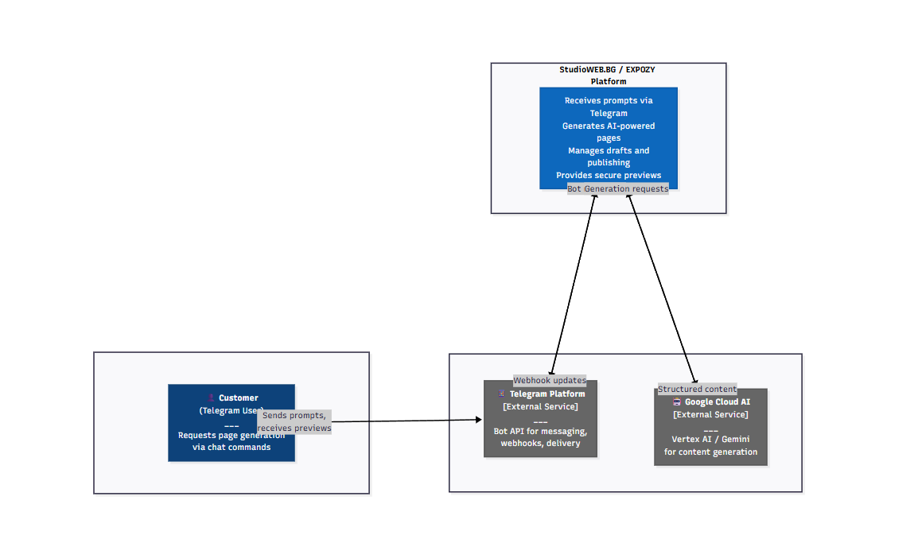
Figure 1. C1 System Context (Level 1) for EXPOZY
Actors and External Systems
At the system context level, EXPOZY is treated as a single system that enables customers to generate and preview web pages from natural-language prompts submitted through Telegram. The primary actor is the Customer (Telegram user), who interacts exclusively through Telegram by sending prompt messages and receiving preview links. This choice leverages Telegram's existing conversational interface and identity model, avoiding the need to build and maintain a custom chat client while still enabling fast feedback loops and iterative prompting.
Telegram is modeled as an external system because it owns the communication channel, user identity, and message delivery. It provides the Bot API and webhook delivery mechanism that forwards user messages to EXPOZY-controlled infrastructure and allows EXPOZY to send responses back to the user. From EXPOZY's perspective, Telegram is a dependency that transports requests and responses but does not contain business logic or data ownership.
Google Cloud AI (Vertex AI / Gemini) is the external dependency responsible for generating the page content. EXPOZY submits structured prompts with schema constraints and receives generated content that must be parsed and validated before it can be previewed or published. This dependency is kept outside the EXPOZY boundary to make it explicit that generation latency, availability, and quota behavior are controlled by a third-party provider and that credentials and integration logic should be isolated to reduce risk and simplify future replacement if needed.

C2 System Context
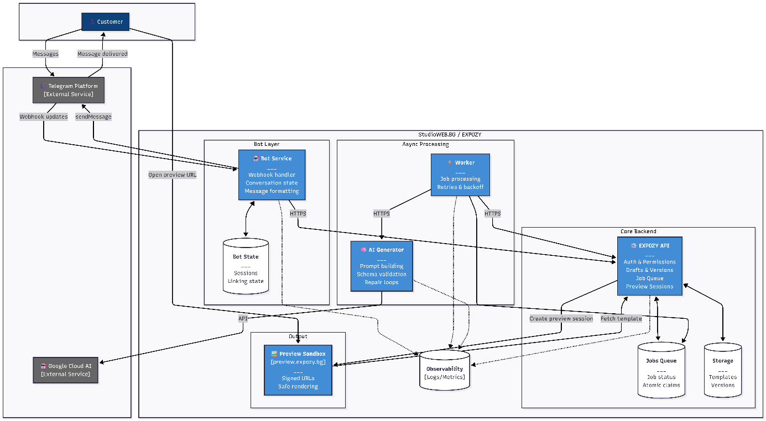
Figure 2. EXPOZY container architecture
Customers interact with the system exclusively through Telegram by sending messages that Telegram delivers to the Bot Service via webhook updates (Telegram, n.d.-b). The Bot Service is responsible for the conversational interface: it receives webhook events, maintains conversation/linking state in a dedicated Bot State store, formats responses, and uses Telegram's Bot API methods (for example, sendMessage) to send status updates and preview links back to the user through Telegram (Telegram, n.d.-a). The EXPOZY API acts as the control plane and system of record by enforcing authentication and permissions, storing drafts and versions, and creating preview sessions. When a generation request is received, it records work in a database-backed jobs queue rather than calling the AI provider inline so the user-facing flow remains responsive and failures can be handled deterministically. The background Worker process then claims queued jobs and applies retry and backoff policies that are appropriate for transient AI-provider failures and rate limiting, which Google explicitly recommends addressing by retrying after a short delay and by using backoff strategies for 429/resource exhaustion conditions (Google Cloud, n.d.-c; Google Cloud, n.d.-d; Melendez & Dalida, 2024). The Worker invokes the internal AI Generator service, which builds a schema-constrained prompt and calls Google Cloud AI. Google documents "structured output" (JSON-schema-like response schemas) specifically to produce predictable, machine-parseable outputs, which aligns with generating page templates as validated JSON rather than free-form text (Google Cloud, n.d.-e; Google, n.d.). When generation succeeds, the Worker persists the validated result back through the EXPOZY API into template storage and marks the job complete, after which the API creates a signed preview session and the Bot Service delivers the resulting preview link back to the user via Telegram (Telegram, n.d.-a). When the customer opens the preview URL, the Preview Sandbox hosted at preview.expozy.bg fetches the template from the EXPOZY API and renders it safely using allowlisted components and browser-enforced restrictions. This is reinforced by deploying a strict Content Security Policy (CSP), which is widely recommended as defense-in-depth to reduce the impact of script injection and related web threats (MDN Web Docs Contributors, 2025; OWASP Foundation, n.d.-d). Observability is represented as a shared concern across the Bot Service, API, Worker, and AI Generator so that logs and metrics can be used to monitor latency, retries, validation failures, and overall reliability.

C3 Component Diagrams
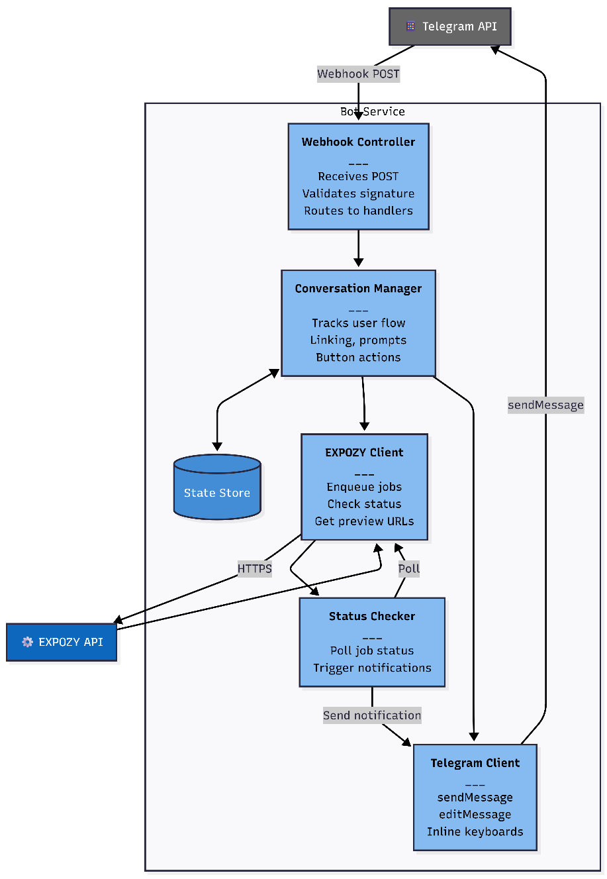
Figure 3. Bot Service Components
This diagram zooms into the Bot Service container and explains how Telegram messages are turned into backend actions and user replies. The flow begins when Telegram delivers an incoming update to the webhook endpoint, which is handled by the Webhook Controller (Telegram, n.d.-b). That controller verifies the request and routes the message into the Conversation Manager, which is responsible for managing multi-step chat flows such as linking a Telegram user to a tenant, collecting prompts, and handling button actions. Conversation state is persisted in the State Store so that the bot can resume flows across multiple messages and server instances. When the bot needs to perform a platform action, such as starting generation or requesting a preview link, it uses the EXPOZY Client to call the EXPOZY API over HTTPS. Because AI generation is asynchronous, the bot also includes a Status Checker that periodically polls job status via the EXPOZY Client. When the job completes, it triggers a user notification. All outgoing communication back to Telegram is encapsulated in the Telegram Client, which uses sendMessage and editMessage (and optional inline keyboards) to present progress updates and deliver the preview link.
C3.2 EXPOZY Backend API Components
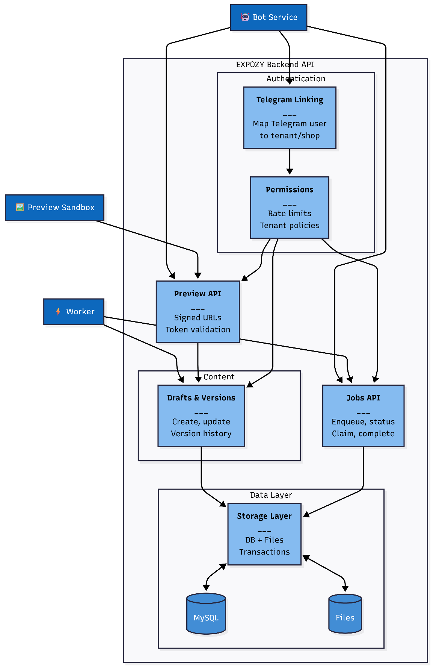
Figure 4. Backend API Components
This diagram zooms into the EXPOZY Backend API container and shows why it is the system of record and control plane for the platform. Requests enter from multiple internal callers primarily the Bot Service, the Worker, and the Preview Sandbox and are processed through business controls. Telegram Linking maps a Telegram identity to a tenant or shop so that actions can be scoped correctly. Permissions then enforces authorization and rate limits. Drafts & Versions manages the lifecycle of generated content by creating drafts, writing new versions, and preserving history for review and rollback. The Jobs API provides a stable interface for enqueuing generation work and tracking execution state, which enables the asynchronous model used by the Worker. The Preview API issues signed, expiring preview sessions and validates preview tokens, enabling safe distribution of preview links without exposing internal identifiers. Finally, the Storage Layer abstracts the persistence of templates and versions across MySQL and file storage, allowing the rest of the API to treat storage as a transactional system rather than scattered SQL/file operations.

C3.3 Worker Components
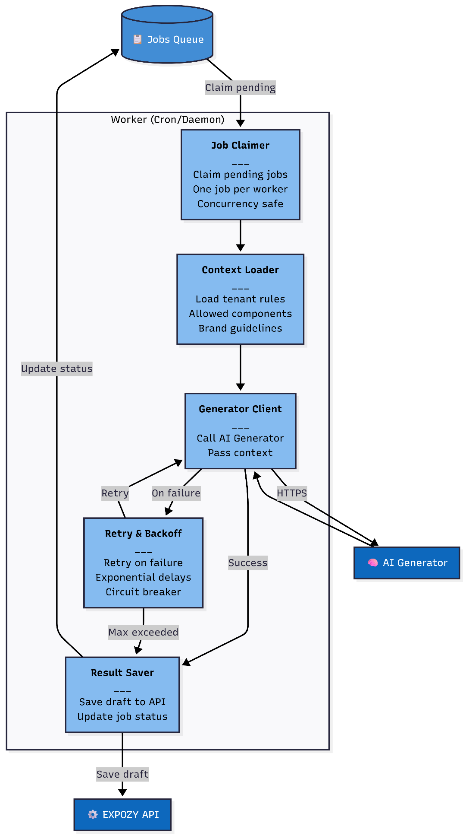
Figure 5. Worker Components
The Worker executes generation jobs asynchronously, preventing long-running AI calls from blocking web server capacity. It runs as a cron job, continuously polling for pending work and orchestrating the generation pipeline. The Job Claimer acquires pending jobs from the queue. This ensures that even when multiple worker instances run in parallel, each job is processed exactly once, preventing duplicate generation and wasted resources. Once a job is claimed, the Context Loader gathers tenant-specific configuration needed for generation. This includes the list of allowed component types, brand guidelines, and schema constraints. By loading this context before calling the AI service, the Worker ensures that generated content will conform to tenant requirements. The Generator Client invokes the AI Generator Service over HTTPS, passing both the user's prompt and the loaded context. It waits for the response and handles the communication protocol, keeping the Worker logic clean and focused on orchestration. When the AI service fails due to transient issues such as timeouts or rate limits, the Retry and Backoff component manages recovery. It re-attempts the request with increasing delays between attempts, reducing pressure on the failing service. A circuit breaker prevents repeated calls when the service is degraded, allowing the system to fail fast rather than accumulate stuck jobs. After generation succeeds or retries are exhausted, the Result Saver persists the outcome. For successful generations, it saves the draft through the backend API. Regardless of outcome, it updates the job status in the queue so that downstream systems can notify the user and the job is not re-processed.

C3.4 AI Generator Service Components
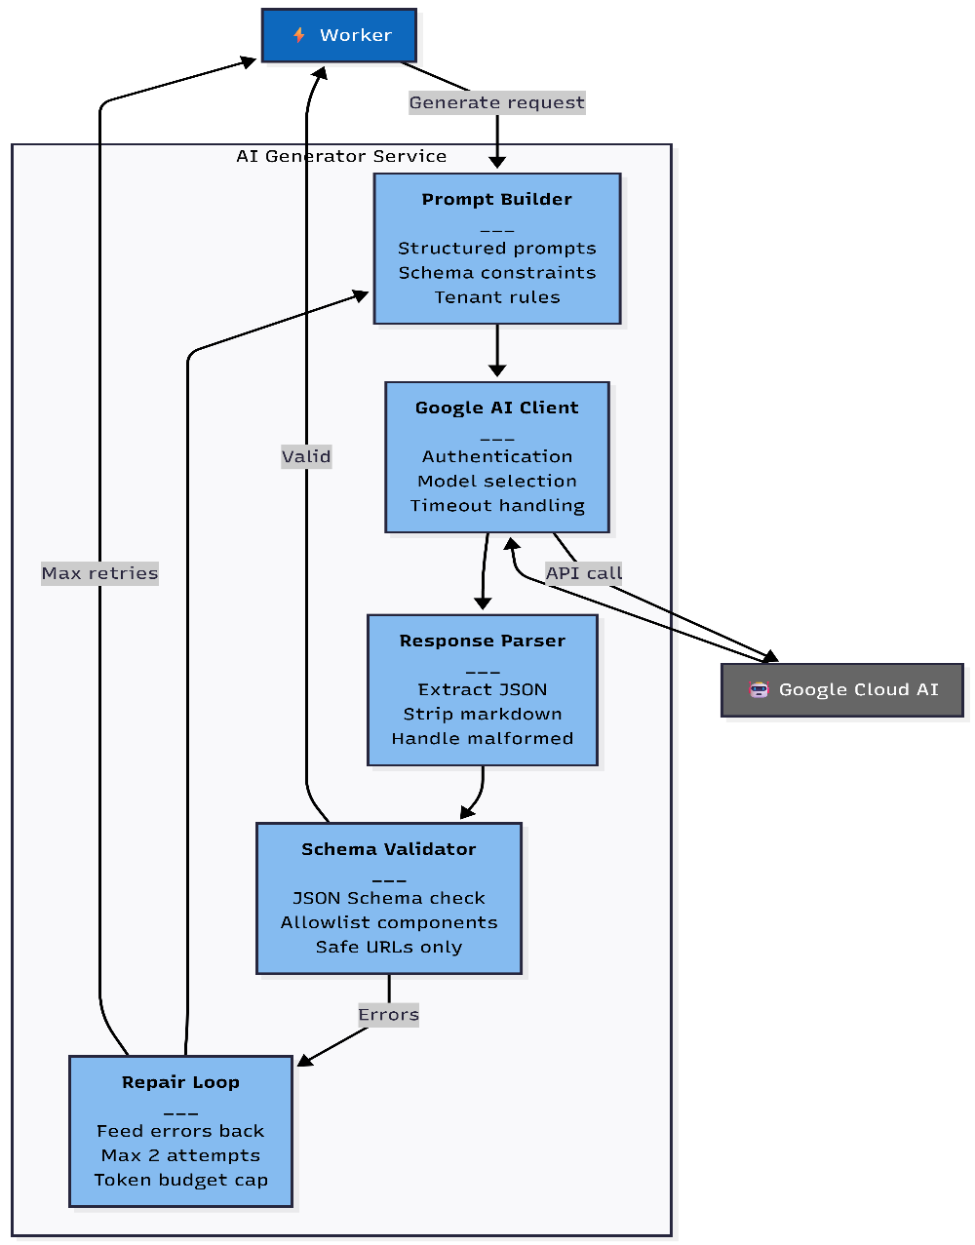
Figure 6. AI Generator Service Components

The AI Generator container converts raw model output into safe, usable templates by enforcing structure and validation at the boundary to the AI provider. The flow starts when the Worker submits a generation request to the Prompt Builder, which composes the final prompt using schema constraints and platform rules so the model output is predictable and machine-parseable (Google, n.d.; Google Cloud, n.d.-e). The Google AI Client then performs the request to Google Cloud AI, handling authentication and selecting the target model endpoint (Google Cloud, n.d.-f; Google Cloud, 2025). Because generation calls are network operations, the client must also handle request deadlines/timeouts. Google's Vertex AI error reference notes DEADLINE_EXCEEDED cases when client deadlines are too short and recommends using a longer deadline or the server default (Google Cloud, n.d.-b). The Response Parser extracts the structured template payload from the response and normalizes it so downstream validation can run reliably; the need for strict parsing is reduced when structured outputs are used, because response schemas are designed to produce valid JSON that conforms to the schema (Google Cloud, n.d.-e). The Schema Validator then verifies that the result conforms to the Template Schema and enforces allowlists (for example, only permitted component types and safe URL patterns), which aligns with OWASP guidance recommending allowlist validation as a robust input validation strategy (OWASP Foundation, n.d.-c). If validation fails, the Repair Loop re-attempts generation for a bounded number of tries, and the system caps token/length budgets to control runtime and cost: Vertex AI supports limiting output length via maxOutputTokens (Google Cloud, n.d.-g), and Vertex AI pricing is usage-based (per token/character depending on the model/product), so bounding attempts and output size directly constrains spend (Google Cloud, n.d.-h). The generator returns either a validated template package or a structured failure report back to the Worker, making this service the enforcement point for correctness and safety of AI-produced templates (Google, n.d.; Google Cloud, n.d.-e).
C3.5 Preview Sandbox Components
This diagram zooms into the Preview Web/Sandbox, which is responsible for displaying generated content safely. The preview link behaves like a signed, time-limited "bearer" URL: anyone who possesses it can access the preview until it expires, so it must be treated as sensitive and short-lived (Cloudflare, 2025; Google Cloud, n.d.-a). The Preview Route validates token and expiration early. if valid, the Template Fetcher retrieves template JSON from the EXPOZY API; and the Safe Renderer renders only allowlisted components and escapes user-controlled strings to prevent injection. Defense in depth is strengthened by security headers especially CSP because CSP is widely documented as a way to reduce the impact of script injection and related web threats by restricting what the browser is allowed to load/execute (MDN Web Docs Contributors, 2025; OWASP Foundation, n.d.-d).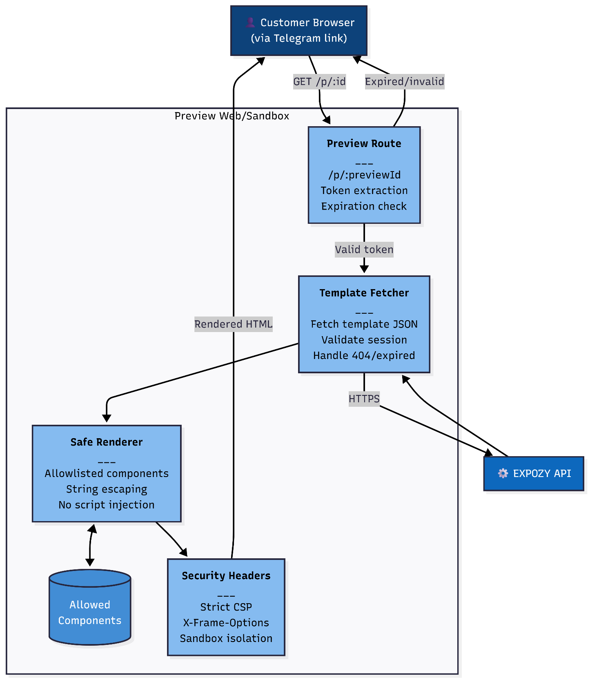
Figure 7. Preview Sandbox Components

Customer Flow
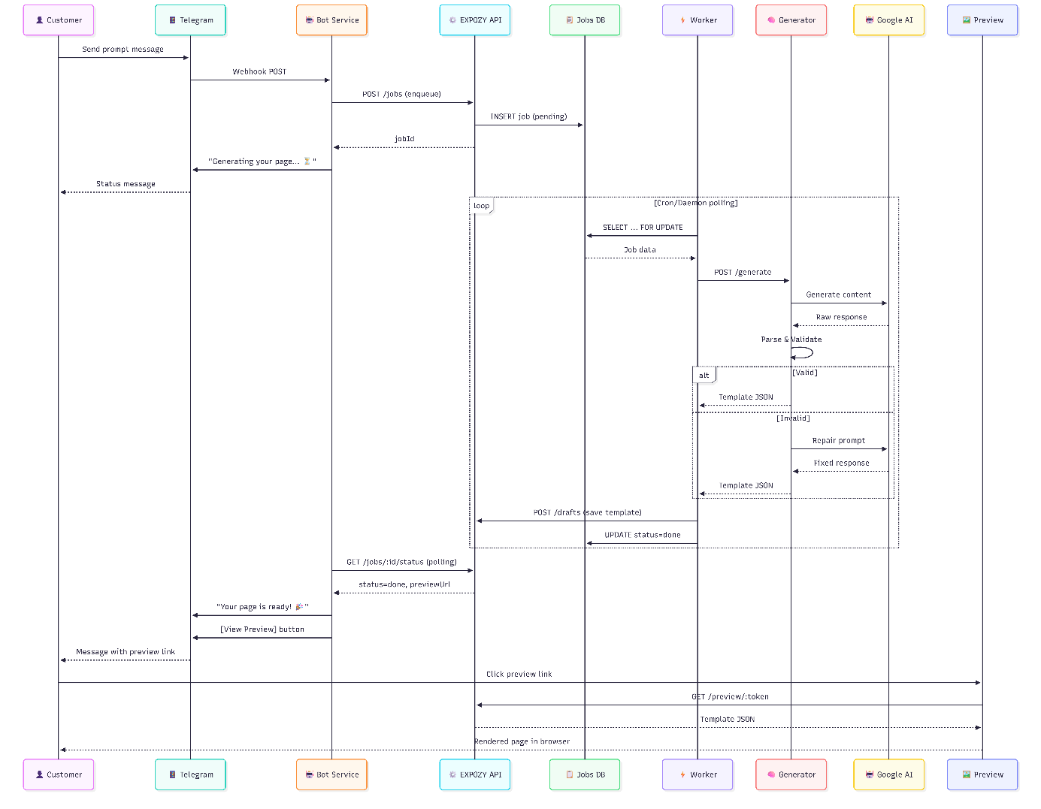

3. Key Design Decisions (ADRs)
The architecture is guided by a small number of deliberate decisions that reflect both the technical constraints of the current EXPOZY backend and the operational requirements of AI-driven page generation. The first major decision is to implement the job queue using a MySQL table. This choice is driven by practicality: the database already exists in production, the backend already relies on database-backed persistence, and introducing a new queue system (Redis pub/sub, RabbitMQ, SQS) would add infrastructure and operational complexity. A database table also provides durable job state, supports auditing, and makes it straightforward to track attempts, errors, and completion times, while still fitting the well-known "web → queue → worker" separation used for long-running workflows (Microsoft, 2026; Oracle, n.d.).
The second decision is to handle asynchronous processing through a cron/daemon Worker. In the current PHP/Apache environment, long-running upstream calls cannot safely execute inside a single HTTP request without risking timeouts and consuming limited web-worker capacity. Apache's process/thread model is finite, and threads/processes can be held waiting on connections, reducing capacity for new requests (Apache Software Foundation, n.d.). PHP also has a configurable maximum execution time, which increases the likelihood that slow external calls will be cut off if kept inside the normal request path (The PHP Group, n.d.). Since the platform already supports CLI execution via scheduled jobs, the Worker approach matches existing deployment and monitoring patterns (The Open Group, 2017).
The third decision is to isolate AI integration into a separate AI Generator Service instead of embedding Google Cloud AI calls directly into the main backend. This reduces the blast radius of sensitive credentials, centralizes prompt construction and schema enforcement logic, and allows generation-specific scaling and deployment without affecting core platform APIs. It also aligns with common key-management guidance that emphasizes controlling where keys live, how they are accessed, and how they are rotated (OWASP Foundation, n.d.-a). Because the system expects structured outputs, schema-based validation is also a natural fit for enforcing the shape of generated JSON before it is stored or rendered (JSON Schema Authors, n.d.).
The fourth decision concerns preview delivery: the system uses signed, expiring URLs. This design enables users to open previews immediately in Telegram's in-app browser without requiring a full login flow or additional authentication complexity on the preview domain. The security model matches the signed-URL approach described in Google Cloud documentation: access is granted to anyone holding the URL until its expiration time, which reduces friction while still limiting exposure (Google Cloud, n.d.-a).
Finally, the architecture uses dual validation in both the AI Generator and the Preview Sandbox. The generator validates structure and safety before storing output, but the preview renderer validates again at render time. This defense-in-depth approach is important for AI systems because model output can be malformed or adversarially influenced, and relying on a single gate increases risk; OWASP guidance similarly frames controls like CSP as an additional layer rather than the only defense (OWASP Foundation, n.d.-b).
3.1. Security Considerations
The system is designed with the assumption that model outputs and user prompts are untrusted inputs. To mitigate prompt injection and malformed content, the AI Generator enforces schema validation and allowlisted components, ensuring that the output is constrained to the template vocabulary that the platform can safely render. This is consistent with OWASP guidance emphasizing allowlist-based validation as a primary way to prevent improperly formed or dangerous data from entering a system (OWASP Foundation, n.d.-c).
Cross-site scripting risks are addressed primarily at the rendering boundary. The Preview Sandbox uses a safe renderer that escapes user-controlled strings and renders only known, allowlisted components, and it enforces strict browser security headers such as Content Security Policy. OWASP's XSS guidance explicitly treats CSP as an allowlist layer that helps reduce impact even when other controls fail, rather than a replacement for proper output encoding and safe rendering (OWASP Foundation, n.d.-b; OWASP Foundation, n.d.-e).
Unauthorized access is mitigated through signed preview tokens with explicit expiration. Users are not granted broad access to templates; instead, they receive a narrow, time-limited capability that only permits previewing a specific draft. This mirrors the security property of signed URLs: the holder gets time-limited access defined by an expiration value (Google Cloud, n.d.-a).
Credential exposure is limited by isolating AI provider credentials inside the AI Generator service rather than distributing them across the bot or core backend. This reduces the number of components that ever see the secret material and supports better lifecycle control, which aligns with key-management best practices (OWASP Foundation, n.d.-a).
Abuse prevention is handled at the backend control plane through tenant policies and rate limits. This is especially relevant for AI features because requests consume CPU/network resources and can create direct operational cost. OWASP's API Security guidance explicitly calls out "unrestricted resource consumption" and the need for appropriate limiting to protect availability and cost (OWASP Foundation, 2023).
3.2. Failure Modes & Resilience
The architecture assumes that failures will occur and designs predictable behavior for each case. If Google Cloud AI requests fail due to timeout or transient errors, the Worker retries using a backoff strategy up to a fixed maximum number of attempts, ensuring that temporary provider instability does not immediately translate into user-facing failures. Google's Vertex AI Generative AI documentation describes overload and quota/capacity conditions (including HTTP 429) and explicitly recommends retrying after a short delay, and Google's retry-strategy guidance describes exponential backoff as the standard approach for retrying transient failures (Google Cloud, n.d.-b; Google Cloud, n.d.-c; Google Cloud, n.d.-d). If the queue begins to back up, monitoring and alerting can surface rising job latency, and a circuit breaker can reduce pressure by temporarily limiting calls to a failing dependency to prevent cascading failures, which is a well-established resilience pattern (Fowler, 2014).
Invalid or non-conforming AI output is treated as a normal possibility rather than an exceptional edge case. The AI Generator implements a bounded repair loop that re-prompts using validation errors to improve the likelihood of producing a valid template, but it caps attempts to control cost and prevent infinite loops. The structured-validation premise is consistent with using schema constraints to ensure generated JSON is well-formed and conforms to expected structure before downstream use (JSON Schema Authors, n.d.).
Preview tokens are explicitly time-limited; if a user opens an expired link, the Preview Sandbox returns a clear error and the bot can generate a fresh preview session. This ensures that token expiration is a safe failure mode rather than a confusing user experience, and it aligns with signed-URL behavior where access is rejected after the expiration time (Google Cloud, n.d.-a).

References
Apache Software Foundation. (n.d.). Apache HTTP Server Version 2.4: Performance tuning. https://httpd.apache.org/docs/2.4/misc/perf-tuning.html
Cloudflare. (2025). Presigned URLs (R2 S3 API documentation). Cloudflare Developers. https://developers.cloudflare.com/r2/api/s3/presigned-urls/
Fowler, M. (2014, March 6). Circuit breaker. https://martinfowler.com/bliki/CircuitBreaker.html
Google. (n.d.). Structured outputs. Google AI for Developers (Gemini API documentation). https://ai.google.dev/gemini-api/docs/structured-output
Google Cloud. (n.d.-a). Signed URLs (Cloud Storage). https://docs.cloud.google.com/storage/docs/access-control/signed-urls
Google Cloud. (n.d.-b). Generative AI on Vertex AI inference API errors. https://docs.cloud.google.com/vertex-ai/generative-ai/docs/model-reference/api-errors
Google Cloud. (n.d.-c). Error code 429 | Generative AI on Vertex AI. https://docs.cloud.google.com/vertex-ai/generative-ai/docs/provisioned-throughput/error-code-429
Google Cloud. (n.d.-d). Retry strategy | Cloud Storage. https://docs.cloud.google.com/storage/docs/retry-strategy
Google Cloud. (n.d.-e). Structured output. Generative AI on Vertex AI documentation. https://docs.cloud.google.com/vertex-ai/generative-ai/docs/multimodal/control-generated-output
Google Cloud. (n.d.-f). Authenticate to Vertex AI. https://docs.cloud.google.com/vertex-ai/docs/authentication
Google Cloud. (n.d.-g). Content generation parameters. Generative AI on Vertex AI documentation. https://docs.cloud.google.com/vertex-ai/generative-ai/docs/multimodal/content-generation-parameters
Google Cloud. (n.d.-h). Vertex AI pricing (Generative AI on Vertex AI). https://cloud.google.com/vertex-ai/generative-ai/pricing
Google Cloud. (2025, September 5). Method: models.generateContent. Generative AI on Vertex AI REST reference. https://docs.cloud.google.com/vertex-ai/generative-ai/docs/reference/rest/v1/projects.locations.publishers.models/generateContent
JSON Schema Authors. (n.d.). JSON Schema: Specification and documentation. https://json-schema.org/
MDN Web Docs Contributors. (2025, November 30). Content Security Policy (CSP). MDN Web Docs. https://developer.mozilla.org/en-US/docs/Web/HTTP/Guides/CSP
Melendez, P., & Dalida, M. (2024, November 22). Don't let resource exhaustion leave your users hanging: A guide to handling 429 errors. Google Cloud Blog. https://cloud.google.com/blog/products/ai-machine-learning/learn-how-to-handle-429-resource-exhaustion-errors-in-your-llms
Microsoft. (2026). Web-Queue-Worker architecture style. https://learn.microsoft.com/en-us/azure/architecture/guide/architecture-styles/web-queue-worker
Oracle. (n.d.). MySQL InnoDB locking reads (SELECT ... FOR UPDATE). https://dev.mysql.com/doc/refman/8.0/en/innodb-locking-reads.html
OWASP Foundation. (n.d.-a). Key management cheat sheet. https://cheatsheetseries.owasp.org/cheatsheets/Key_Management_Cheat_Sheet.html
OWASP Foundation. (n.d.-b). Cross site scripting prevention cheat sheet. https://cheatsheetseries.owasp.org/cheatsheets/Cross_Site_Scripting_Prevention_Cheat_Sheet.html
OWASP Foundation. (n.d.-c). Input validation cheat sheet. https://cheatsheetseries.owasp.org/cheatsheets/Input_Validation_Cheat_Sheet.html
OWASP Foundation. (n.d.-d). Content Security Policy cheat sheet. https://cheatsheetseries.owasp.org/cheatsheets/Content_Security_Policy_Cheat_Sheet.html
OWASP Foundation. (n.d.-e). HTTP security response headers cheat sheet. https://cheatsheetseries.owasp.org/cheatsheets/HTTP_Headers_Cheat_Sheet.html
OWASP Foundation. (2023). OWASP Top 10 API Security Risks – 2023 (API4: Unrestricted Resource Consumption). https://owasp.org/API-Security/editions/2023/en/0x11-t10/
Telegram. (n.d.-a). Telegram Bot API. https://core.telegram.org/bots/api
Telegram. (n.d.-b). Marvin's Marvellous Guide to All Things Webhook. https://core.telegram.org/bots/webhooks
The Open Group. (2017). crontab(1p) (POSIX.1-2017). https://www.man7.org/linux/man-pages/man1/crontab.1p.html
The PHP Group. (n.d.). max_execution_time (PHP manual). https://www.php.net/manual/en/info.configuration.php

